Integrating Nature-Based Solutions into Higher Education towards exploiting the transformative potential of Social Economy
for a green and inclusive future



WP4 - Development of the Green SE curriculum
Introductory materials to the theory, methodology & application of NBS
Introduction to international best practices of applying urban NBS in campuses and public spaces

ZERO, 2025
Table of contents:
1. Abstract & keywords 2
2. Introduction to the module & its objectives 2
3. Learning outcomes & target groups (/beneficiaries) 2
4. Introduction the theory, methodology & application of NBS 3
What are Nature-Based Solutions (NBS)? 3
5. International best practices of applying urban NBS in campuses and public spaces 7
Green Roofs 7
Wildlife Corridors 8
Vertical Gardens 8
Biodiverse Green Spaces 9
Community Gardens 10
Nature-Based Learning Approaches 10
Summary of Best Practices 11
6. Competence-based activities & ready-to-use lesson plans 12
World Café - First approach (before any presentation) 12
NBS Categorization Game 14
Nature-Based Solutions Mapping Exercise 16
Capturing Ecosystem Services and NBS: A Creative Photo Challenge 18
Exploring Biodiversity with iNaturalist 21
7. List of online & offline teaching material 23
8. References 23

 Attribution-NonCommercial-ShareAlike 4.0 International (CC BY-NC-SA 4.0)

Abstract & keywords

Nature-Based Solutions (NBS) is a fairly recent concept that congregates multiple types of solutions (ecological engineering, green/blue infrastructure, land-use planning, etc.) and it has been a very important cornerstone of the european strategy for biodiversity conservation. Since 2013, the European Union (EU) has started using the term NBS within their discussions around sustainable urban development and from 2015 onwards it has started funding projects with a clear goal of scaling up the use of these solutions ⁽¹⁾
But what are NBS? There is no unified clear definition. However, we can summarize it by saying that NBS are solutions that help Humanity solve or attenuate one or multiple specific problems, while simultaneously promoting and fostering the increase in biodiversity.
In this module, we will dive deeper into that concept and how can we simultaneously develop Nature while maximizing the usage of its services for our own quality of life.
At the end, some examples will be given around the application of NBS in university campuses and activities that can be done with university students of different levels around this topic.
Keywords: Nature-Based Solutions, Ecosystem Services, Biodiversity, University, Campus, Learning activities

Introduction to the module & its objectives
This module is aimed at giving an overview of the concept of Nature-Based Solutions and how it can be applied in university campuses. The goal is to introduce and inspire the application of this methodology, beginning with concrete examples in university campuses that may be the starting point of ideas to further expand the scope of applications of NBS in other areas and fields.
The module includes 3 ready-to-use lesson plans that can be helpful for educators to develop activities with students and kick-start their knowledge around NBS.

Learning outcomes & target groups (/beneficiaries)
With this module, you will be able to understand clearly what is and what isn’t a NBS, differentiating the wider concept of environmental solutions (for instance solar panels) from the specific concept of NBS. You will also understand what were the environmental/social problems that forced the concept of NBS to emerge and what is the design process for this type of solutions.
The beneficiaries of this module are university students and educators with no background in ecology, biology or engineering, that want to develop their knowledge in NBS.

Introduction the theory, methodology & application of NBS
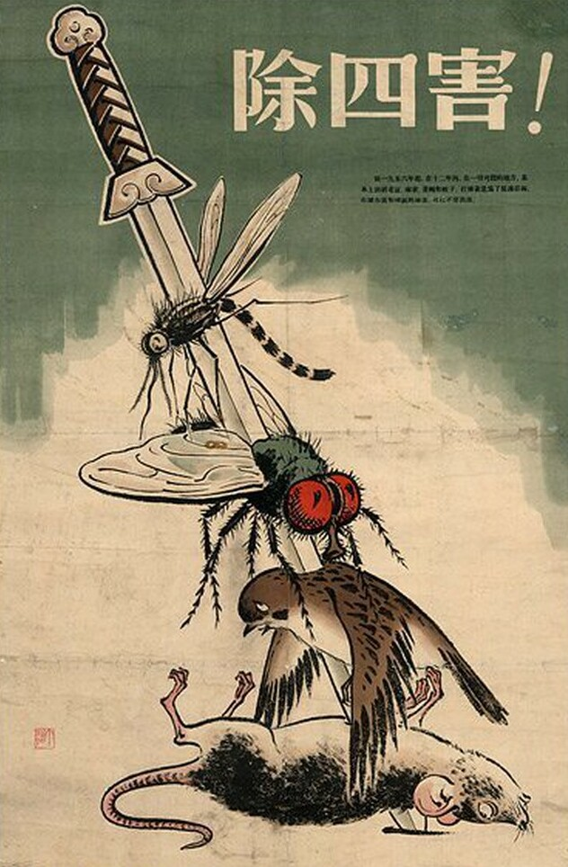
Why is this topic important?
Humanity faces two critical ecological crises: climate change and biodiversity loss at an extinction-level scale. These crises, combined with other social and economic challenges, reveal the limitations of our current technological systems in addressing these issues without exacerbating others.
A historical parallel can be drawn with China in the late 1950s, where an effort to eliminate pests, including sparrows, led to ecological imbalance. The absence of sparrows allowed locusts to thrive, contributing to the Great Chinese Famine and demonstrating the dangers of narrow-focused solutions.
Figure 1 1958 poster 'Exterminate The Four Pests!'.

Similarly, efforts to combat climate change often worsen biodiversity loss. For instance, renewable energy transitions demand increased extraction of critical minerals, habitat destruction, and significant land use changes. This paradox reflects a tension: transitioning from fossil fuels to renewable energy to reduce greenhouse gases often increases human pressure on nature, intensifying the biodiversity crisis.
To address these interconnected crises, solutions must consider the complexity and paradoxical nature of these challenges. Integrating nature-based approaches can offer sustainable alternatives, reducing reliance on resource-intensive and environmentally damaging methods.
- Humanity is faced with a choice: continue on an unsustainable trajectory or stop and think. Nature offers multiple solutions to the many problems facing humanity today.

What are Nature-Based Solutions (NBS)?

Nature-based Solutions, despite being a relatively new concept from the beginning of this century, are an umbrella term encompassing a variety of practices and actions, some of which have been around for a long time.

In simple terms, NBS is the concept of using Nature to simultaneously solve human problems and promote biodiversity.

To understand this idea more in depth, we have to introduce two very important concepts: Ecosystem Services and Biodiversity.

Since the beginning of our species, nature has been providing services for humans in a variety of ways: producing the oxygen we breathe, pollinating flowers so we can harvest fruits and vegetables to eat, giving shade and cooling the air temperature or increasing water absorption and preventing major floods or landslides.
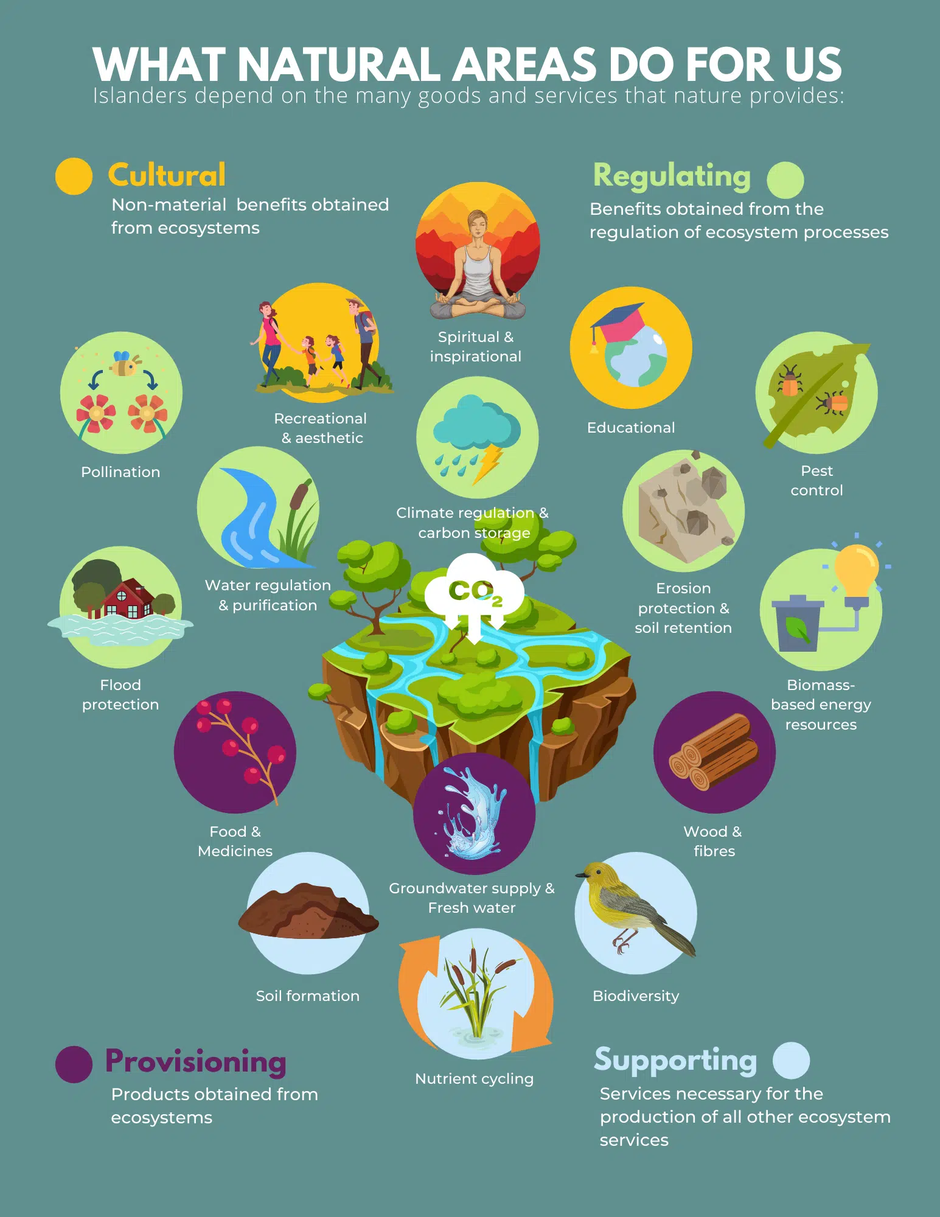
These services are called “Ecosystem Services” (ES) being the contributions that ecosystems provide, directly and indirectly, for human wellbeing and quality of life. This can be in a practical sense, providing food and water and regulating the climate, as well as cultural aspects such as reducing stress and anxiety.

Figure 2 - We can divide ES in four categories: (1) Provisioning, (2) Regulating, (3) Cultural and (4) Supporting ⁽²⁾

Reflection: What do you think are the Educational ES? What are the things that Nature can provide you for free and that can help in Educational endeavors?
Nature's redundancy ensures resilience, as many elements provide multiple ecosystem services (ES), and each service is supported by various elements. For instance, bees provide pollination, honey, and more, while pollination also comes from birds, bats, and insects.
This interconnected network allows ecosystems to adapt when an element is removed, maintaining functionality. Greater diversity and redundancy increase these connections, strengthening the system’s resilience.
The more complex the network of elements and connections, the more resilient the system becomes.To name that complex network of life, a concept was created: Biodiversity.

And so what?
The current global industrial system lacks resilience, as it often prioritizes efficiency by reducing redundancy and specialization. This is at odds with principles of diversity and redundancy. The COVID-19 pandemic highlighted this flaw, causing widespread supply chain disruptions and making essential products scarce.

Integrating Nature, with its redundancy and biodiversity, into our services and solutions is one way of increasing resilience and making us better able to resist the urgent societal challenges we face today.

Enter Nature-Based Solutions (NBS)!
Nature-Based Solutions (NBS) use ecosystem services (ES) to address societal problems while conserving nature and promoting biodiversity. These solutions reduce environmental impacts and offer adaptability, resilience, and cost-efficiency by leveraging nature’s free services. NBS are tailored to challenges by focusing on relevant ES. For flooding, water regulation is key; for pollution, purification services; and for river restoration, soil stabilization. Social challenges can also benefit by prioritizing cultural ES, such as recreation and education.
Reflection: Make a list of specific social challenges in your geographic sphere of influence that currently have not been well addressed or solved and may need more investment and innovation.

Not every lawn is a NBS! Using nature in a solution doesn’t mean it is a NBS
For a solution to qualify as a Nature-Based Solution (NBS), it must function like natural elements, providing multiple ecosystem services simultaneously. Using elements like grass in a lawn may not meet NBS criteria if it serves only a single purpose, such as leisure, without enhancing biodiversity or supporting diverse ecosystem services.

NBS: an umbrella concept with 3 different types
To better understand NBS, we need to understand that NBS is an umbrella term that encompasses a wide range of actions and solutions, which can be put in a spectrum between nature conservation measures (such as the establishment of protected areas) to engineering solutions that use single natural elements (such as designing a system that uses bacteria to clean blackwater).

These wide spectrum brought the need to create 3 types of NBS:
Type 1: Use of Natural Ecosystem
Focus on conservation of entire ecosystems so that they keep providing a wide variety of ES (for example: the establishment of marine protected areas to conserve biodiversity within these areas and thus promoting, amongst other, the provisioning ES of exporting fish into fishing grounds)

Type 2: Managed or Restored Ecosystem
Implementation of key changes in already existing landscapes (e.g. forest or agriculture) in order to increase its resilience and maximize their delivery of certain ES (for example: shifting from traditional agriculture practices to agroforestry)

Type 3: Creation of a new Ecosystem
Design and development of entirely new ecosystems, small and large scale, with a key ES in mind to be maximized (for example: the previously mentioned case of the river stabilization in Figure 3). This type of solution is more framed in integrating specific actions in the economic system.

Reflection: Returning to the list of challenges that you may have created before, think about what Ecosystem Services could be provided to help mitigate those challenges for each challenge you’ve listed before. In a nutshell, what services provided by nature can be leveraged to help solve those challenges one by one?
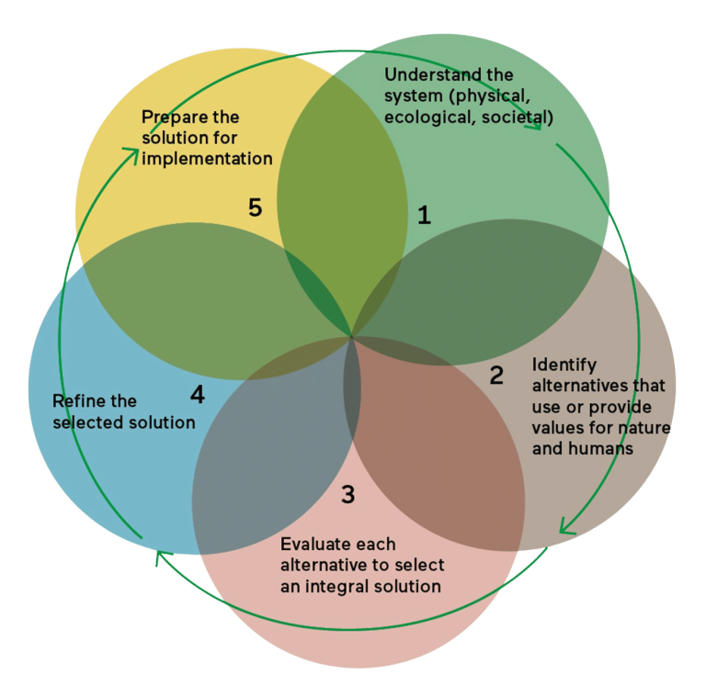
Methodology for the development of NBS
The implementation process for each NBS type will differ, since they have different goals and starting points. Understanding the initial system (physical, ecological, societal) and defining the goal of the NBS are the first steps for its implementation. However, since we are working directly with the constantly changing and adaptive Nature and not with rigid and fixed material (such as concrete or iron), the implementation process of NBS resembles more a constant cycle than a linear process.

Figure 3 - The implementation of NBS implies an iterative and adaptive management, resembling a constant cycle where it is necessary to observe and understand, identify alternatives, evaluate, refine, implement and start again by observing the results and understanding the changes.

Challenge: Since Nature is all about connections and diversity, so should be NBS: One of the first steps to design a solution is to investigate your surroundings. Check in this map if you find any NBS that has been implemented in your region: https://casestudies.naturebasedsolutionsinitiative.org/case-search/

International best practices of applying urban NBS in campuses and public spaces
This chapter will showcase successful examples of how universities and schools are integrating NBS into their campuses and surrounding public spaces. These case studies will provide real-world inspiration and practical insights into the implementation of NBS.

Green Roofs
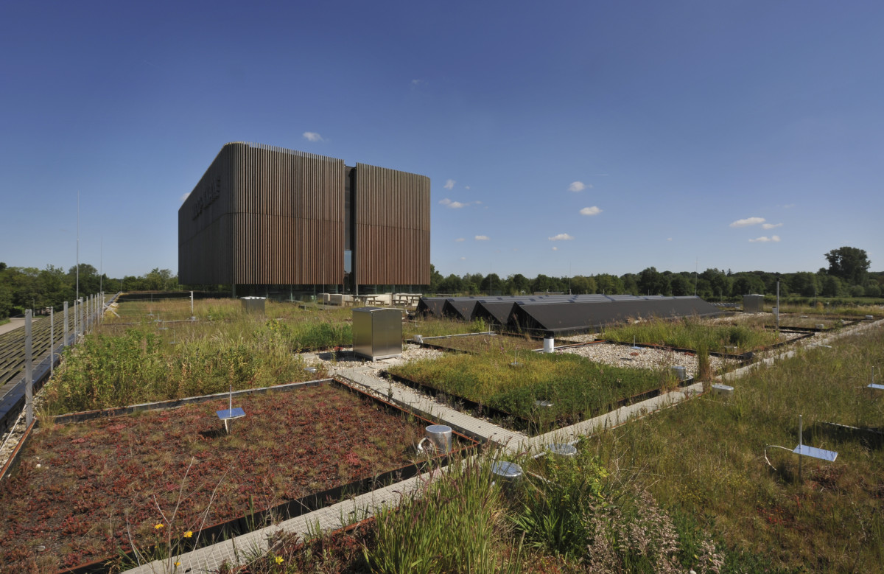
Green roofs are a type of NBS that involves growing vegetation on building rooftops. They help to reduce heat, manage rainwater, and support local biodiversity. Many universities have implemented green roofs as part of their commitment to sustainability.
Wageningen University, Netherlands

Figure 4 - "Green Roof 2.0." NIOO-KNAW

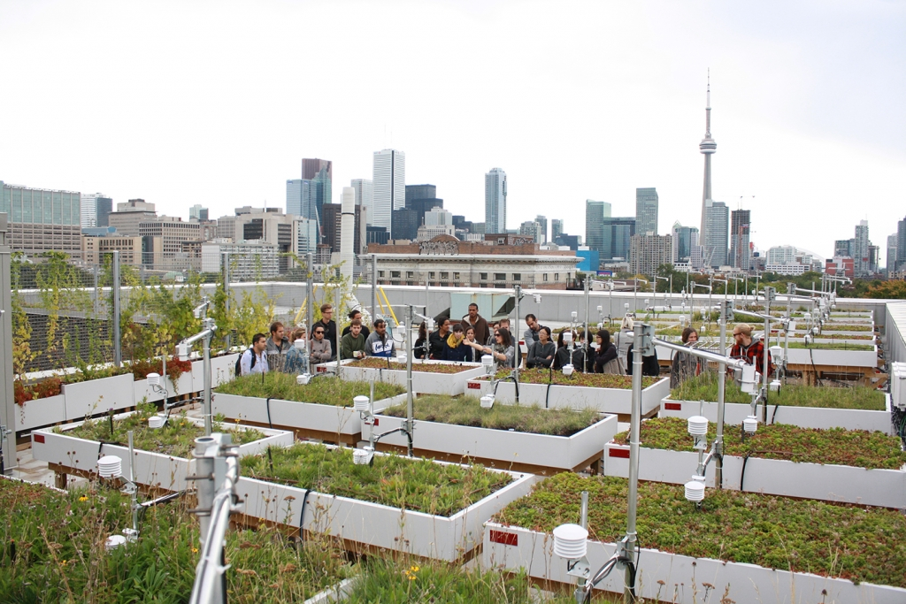
University of Toronto, Canada
The Green Roof Innovation Testing Laboratory (GRIT Lab) allows students to analyze the effectiveness of different green roof systems. Additionally, the Rotman School of Management at the University of Toronto features an extensive living roof that provides outdoor space for faculty and staff.

Figure 5 - "One Spadina Green Roof Innovation Testing Lab (GRIT)." Boundless, University of Toronto

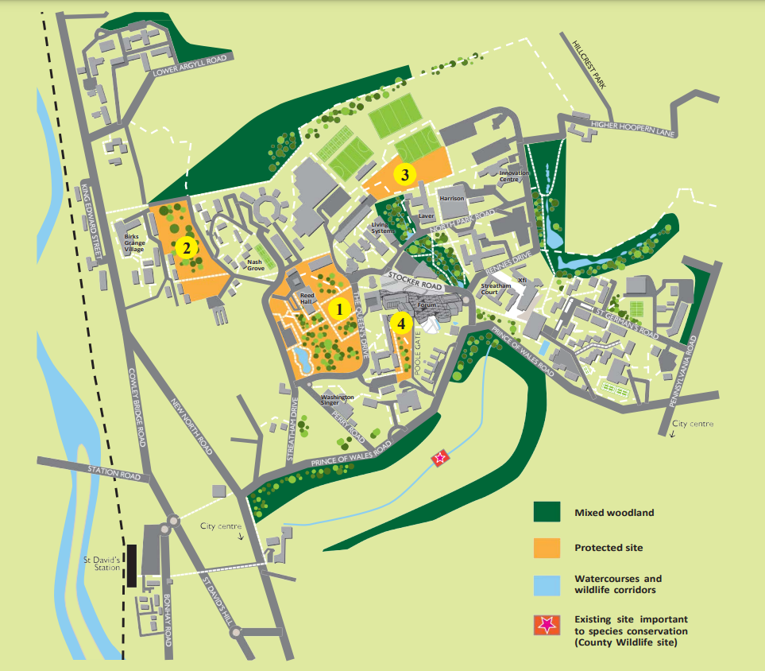
Wildlife Corridors
Wildlife corridors are natural or green spaces that connect habitats, allowing animals and plants to move freely and thrive. On campuses, they provide opportunities for students to engage with conservation efforts and study these corridors as part of environmental courses
Examples:
- University of Exeter, UK: Wildlife corridors connect the campus to nearby natural areas, making it easier for species to move and thrive.

Figure 6 - "Biodiversity Strategy Streatham Campus 2021-2026." University of Exeter

The University of Exeter's Biodiversity Strategy (2021-2026) details a plan to protect and enhance biodiversity across its Streatham Campus. It includes initiatives such as preserving existing habitats like the Reed Hall Arboretum and Birks Bank Arboretum, implementing measures to protect vulnerable species, by installing bat boxes, monitoring bird life and mapping badger dens, and transitioning to a “zero green waste to landfill” university, where all the green waste is used as soil cover and mulch.
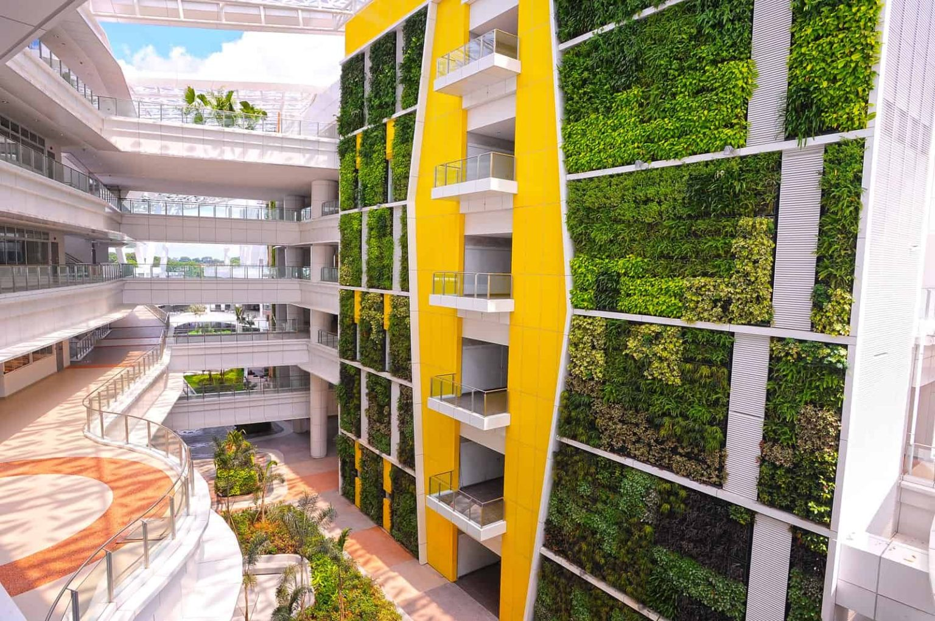

Vertical Gardens
Vertical gardens, or green walls, make efficient use of vertical space to grow plants. They are ideal for urban campuses where space is limited and offer cooling and air-purifying benefits.
Figure 7 - "The Largest Vertical Garden in the World." at the University of Singapore

- University of Singapore
Singapore's Institute of Technical Education (ITE) College Central hosts the world's largest vertical garden, covering 5,300 square meters across eight campus blocks and standing 35 meters tall. Constructed by Elmich using their VersiWall system, the garden highlights the institution's eco-friendly initiatives. For more details, visit MetaEfficient.
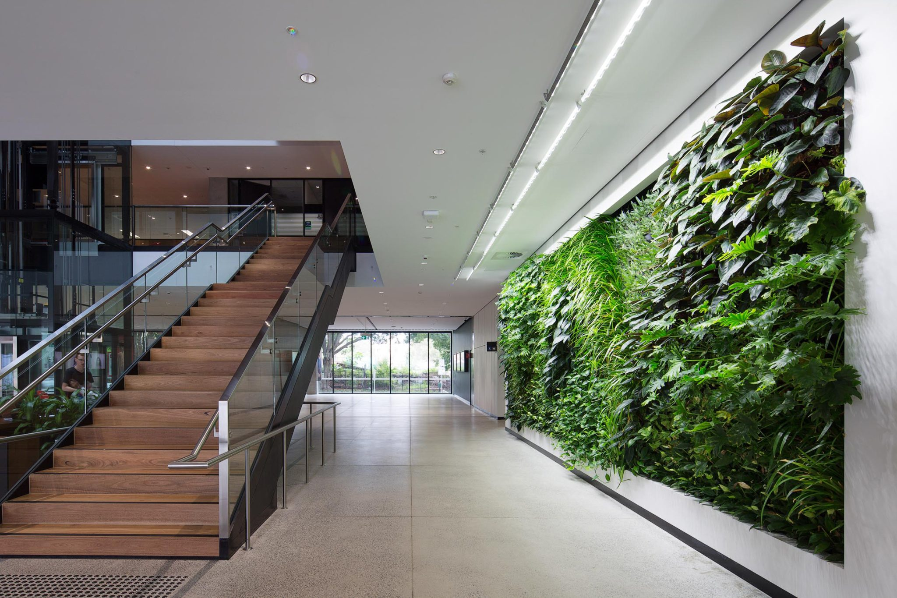
- University of Sydney, Australia
40 m² vertical garden with Sunlite LED lighting were installed in the University of Sydney's F23 Admin Building, providing ecosystem services like air purification and biophilic benefits in a low-light setting.
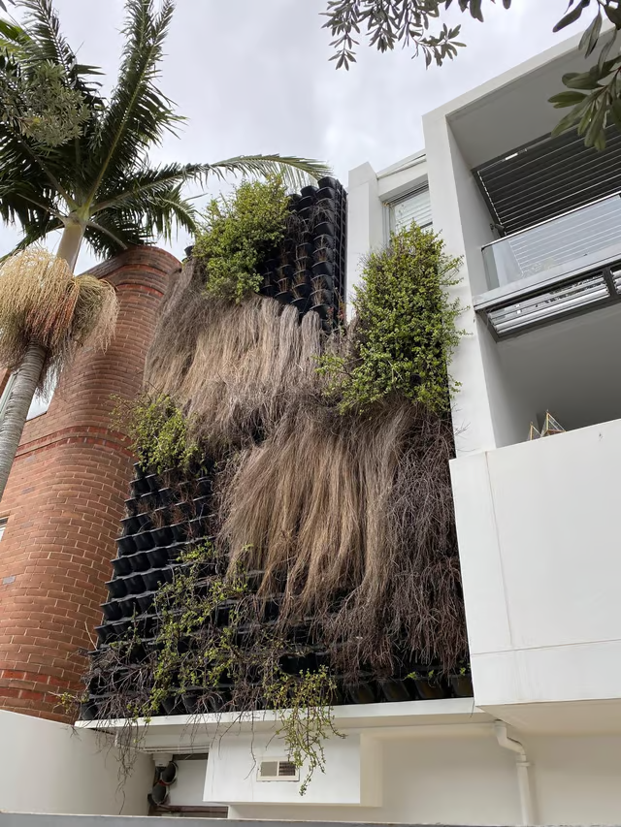
Figure 8 - "University of Sydney F23."

It is also important to notice one of the main challenges of living green walls which is maintenance, as they require regular care such as consistent watering, trimming, and managing pests to keep the plants healthy.

Figure 9 - "Living Green Walls Are Having a Moment but Face a Steep Challenge."

Biodiverse Green Spaces
Biodiverse green spaces are areas planted with native vegetation to support local wildlife. They provide opportunities for research and learning about ecosystems.
- University of Edinburgh, UK: Biodiverse meadows on campus offer students a chance to learn about native species and conservation.

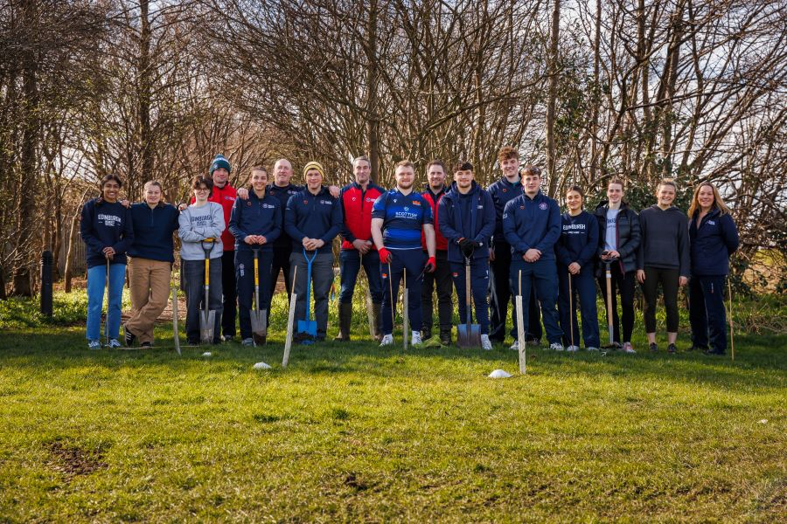
Figure 11 - “Wild Peffermill Big Dig”

The "Wild Peffermill Big Dig" event was a volunteer-driven initiative focused on restoring natural habitats at the Peffermill Playing Fields, part of the University of Edinburgh's sustainability efforts. Volunteers helped plant native trees, sow wildflower meadows, and improve woodland areas to support local wildlife. This work is a part of the university's broader commitment to enhancing biodiversity and creating a more nature-positive environment.

Community Gardens
- University of Murcia, Spain: Eco-Campus Community Gardens - Huerto Eco-Campus
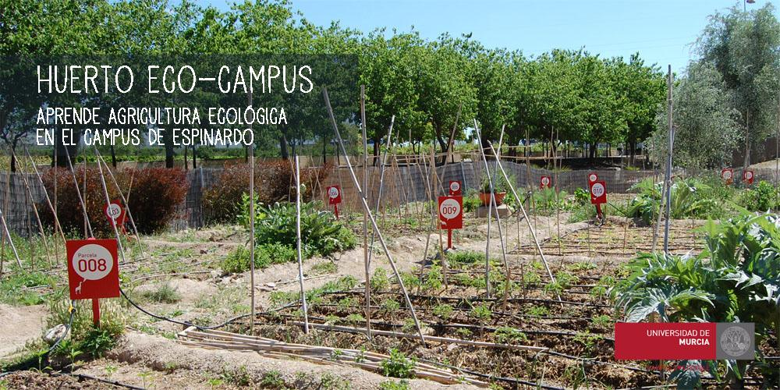
Figure 12 - Eco-Campus Community Gardens (Huerto Eco-Campus)

The Eco-Campus Community Gardens (Huerto Eco-Campus) at the University of Murcia, Spain, are a sustainable agricultural space covering around 900 square meters. Established between 2007 and 2009, they offer individual plots for cultivation and a communal garden to foster social interaction, education, and biodiversity conservation. Participants engage in organic farming practices, learning about agroecology and food sovereignty. The gardens also promote community cohesion, with tools and resources shared among users. The project aligns with the university's sustainability goals, integrating green spaces into academic life

Nature-Based Learning Approaches
Nature-based learning connects education with practical, outdoor experiences, helping students engage with NBS in meaningful ways.
- University of Cape Town, South Africa: Students work on community-based projects such as restoring wetlands, linking classroom knowledge with real-world applications.
The Green Campus Initiative (GCI), established in 2007 at the University of Cape Town (UCT), is a student-led organization dedicated to promoting sustainability and environmental consciousness within the university community. Over the years, GCI has grown into a dynamic group comprising students and staff, all working collaboratively to make UCT a more environmentally friendly institution. Check their instagram
GCI undertakes a variety of projects to promote sustainability:
- Recycling Programs: Implementing campus-wide recycling initiatives to manage waste effectively.
Green Week: An annual event featuring debates, screenings, interactive displays, and an expo to raise awareness about environmental issues.
- Ridelink: A carpooling system that encourages students to share rides, reducing carbon emissions and promoting sustainable transport.
- Residence Projects: Establishing recycling systems in student residences to manage waste effectively.
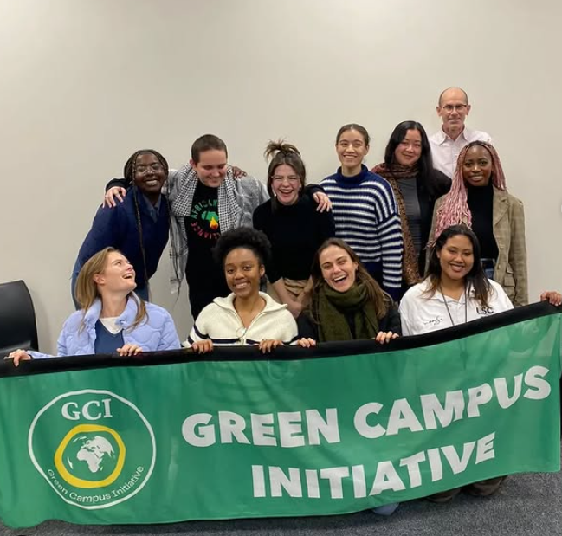
- Outreach Programs: Engaging with local schools and communities to promote environmental education and sustainability practices.
Figure 13 - Green Campus Initiative (GCI)

Summary of Best Practices
These examples show how Nature-Based Solutions (NBS) can transform your campus into a sustainable and engaging learning environment. Here are key points to keep in mind:
- Learning by Doing: Engage in hands-on NBS projects to apply knowledge in practical, real-world scenarios.
- Interdisciplinary Work: Collaborate across fields like ecology, engineering, and design for holistic solutions.
- Community Impact: Partner with local communities to extend NBS benefits beyond campus and tackle broader challenges.
- Continuous Improvement: Monitor and evaluate projects to ensure effectiveness, track progress, and make enhancements.
- Replicability: Design initiatives that inspire adoption by other universities and urban areas, fostering widespread change.
NBS are an exciting way for you to learn about sustainability, tackle global challenges, and improve campus life—not just for you, but for the community around you. Get involved and be part of shaping a sustainable future!

Competence-based activities & ready-to-use lesson plans

World Café - First approach (before any presentation)
Objectives, Competencies and Learning Outcome | Encourage participants to share personal experiences and perspectives about nature.  Spark curiosity and initiate discussions around Nature-Based Solutions (NBS).  Foster collaboration and active participation among students.
NBS topic(s) – if applicable | Introduction to Nature-Based Solutions (NBS).  Exploring benefits and applications of NBS.
Recommended age of students | 15 to 30 years old (flexible for other age ranges).
Skills (21st century, green competences) that the activity promotes | Systems Thinking: Understanding the interconnections between nature, society, and sustainability.  Embracing Complexity in Sustainability: Recognizing and analyzing complex sustainability challenges.  Futures Thinking: Imagining and assessing possible sustainable futures.  Sustainability Values: Reflecting on and promoting values that respect nature and future generations.  Action Competence: Participating in collective actions for sustainability.  Critical Thinking: Questioning assumptions and critically assessing information about environmental issues.
Necessary materials/ resources | Flipcharts or large sheets of paper (one per group).  Colored pens or markers (multiple colors for each table).  Tables and chairs arranged to facilitate group discussions.  Timer or clock for managing time during rounds.  Optional: Presentation to be projected with the questions
Location/Venue | Physical space
Duration (including the preparation and application time) | Total: 1h40 - 2h15 (including preparation and application).  - Preparation: 10 to 15 minutes (setting up materials and explaining the activity).  - Activity: 1h15 to 1h40 (3-4 rounds at 25 minutes each).  - Wrap-up and presentations: 15-20 minutes
Instructions/ How to apply the activity the /lesson plan | Setup:  - Divide students into groups of 4-5 and assign each group to a table.  - Provide each table with a flipchart and colored pens.  - Designate one student as the table representative who remains at the table throughout the activity.  Rounds:  - Pose one question to all groups.  - Each group discusses the question for 15 minutes, with the representative taking notes, making drawings, or recording the group’s thoughts on the flipchart.  - After the discussion, all students except the representative switch tables to mix the groups.  - Representatives have 10 minutes to share the previous group’s responses with the new participants.  - Repeat for 4-5 rounds with different questions.  Presentation:  - At the end of the rounds, groups present their flipcharts to the whole class, summarizing their discussions and key takeaways.  Suggested questions:  - What is Nature for you?  - Describe a memory you have in Nature?  - Is Nature integrated in your classes?  - If yes, in which way do you integrate it?  - If not, how would you do it?  - Do you see any benefits from having classes in or with Nature?  - What are the benefits of this process?  - What do you think Nature-Based Solutions (NBS) are?  - Give some examples.
Involved stakeholders | Environmental experts (optional, as observers or guest speakers).  Local community members (optional, for providing practical examples of NBS).  School staff (optional, to assist in logistical support).
Reflection moments / assessment method | In groups of 2, the participants can have 10 minutes to share with each other:  - What they thought was the best representation of NBS?  - Why?  - If they had to create a new project at school on NBS, what would they do?  Use the flipcharts as an informal assessment of students’ understanding and creativity.
Useful Tips | Encourage creativity: Allow students to express their ideas in various ways (text, drawings, symbols, etc.).  Foster inclusivity: Ensure every participant gets a chance to speak during discussions.  Manage time: Use a timer to keep the rounds and transitions on schedule.  Adapt the questions based on the group’s age or background knowledge.  If possible, introduce a brief nature-related activity (e.g., a short video or an outdoor walk) before the session to set the tone.

NBS Categorization Game
Objectives, Competencies and Learning Outcome | Objectives: Help students distinguish between the three types of NBS; Foster collaboration and discussion to deepen understanding.  Competencies: Analytical thinking: Categorizing examples based on clear criteria; Communication and collaboration.  Learning Outcome: Students will identify and correctly categorize NBS examples into Type 1, 2, or 3.
NBS topic(s) – if applicable | - Types of NBS.
Recommended age of students | - University-level students (ages 18–25).
Skills (21st century, green competences) that the activity promotes | - Critical thinking: Differentiating between types of NBS using real-world cases.  - Collaboration for sustainability: Group discussions to determine correct placements.
Necessary materials/ resources  (online & offline if it is a physical activity) | - Pre-made example cards: Each card contains a brief description of an NBS solution. (Examples provided below.)  - Three large labeled posters or boards: Type 1: Use of Natural Ecosystem, Type 2: Managed or Restored Ecosystem, Type 3: Creation of a New Ecosystem.  - Sticky tape or pins for attaching cards to boards.  Examples:  - "Establishing a marine protected area to conserve biodiversity."  - "Restoring a degraded wetland to improve water filtration and flood control."  - "Designing an urban green roof to reduce heat and absorb rainwater."  - "Switching from monoculture to agroforestry to enhance soil health and biodiversity."  - "Building an artificial reef to protect the coast from waves."  - "Preserving a rainforest to maintain carbon sequestration and biodiversity."  - "Creating a new urban park to improve air quality and provide recreational space."  - "Reforesting degraded land with diverse tree species for carbon capture."
Location/Venue | - A classroom with space for group movement and three designated stations (Type 1, 2, 3).
Duration | - 45-60 minutes
Instructions/ How to apply the activity the /lesson plan | 0. Room Setup:  - Arrange the three labeled boards in different corners of the room.  - Provide a stack of example cards for each group.  - Introduction (5-10 minutes):  - If it wasn’t explained already, briefly explain the three types of NBS and their key characteristics.  - Use simple examples to illustrate each type.  - Grouping (5 minutes):  - Divide students into small groups (3-5 members each).  - Give each group a stack of shuffled example cards.  - Categorization Phase (15-20 minutes):  - Groups work together to decide which type of NBS each card belongs to.  - Once they’ve made their decisions, they attach their cards to the corresponding board (Type 1, 2, or 3).  - Encourage groups to discuss their reasoning for each placement.  - Review and Discussion (15-20 minutes):  - Review the boards as a class.  - For each board, ask a group to explain why they categorized certain cards as that type.  - Discuss any disagreements or incorrect placements, clarifying the distinctions between the NBS types.  - Discuss any placements that may be ambiguous  - Question: “Is there any an NBS that you think could be in any of these panels?”  - Wrap-Up (5 minutes):  - Last reflections (see reflection moments below)
Involved stakeholders | -
Reflection moments / assessment method | - Group discussions about why they categorized examples into specific types.  - Class debrief to address misconceptions and solidify understanding.  - Summarize the differences between the three types of NBS.  - Reflect on how understanding these categories helps in identifying and implementing solutions.
Useful Tips | - Start with simpler examples to build confidence before introducing more complex ones.  - Allow groups to discuss disagreements before revealing correct answers.

Nature-Based Solutions Mapping Exercise
Objectives, Competencies and Learning Outcome | Objective: To teach students how to analyze urban problems and use Nature-Based Solutions (NBS) to propose interconnected, sustainable solutions.  Learning Outcomes:  Understand the characteristics, needs, and outputs of various NBS elements.  Identify urban challenges and align NBS to address these challenges effectively.  Design interconnected NBS systems to provide integrated solutions to urban issues.  Communicate and justify urban planning decisions clearly and effectively.
NBS topic(s) – if applicable | all of them
Recommended age of students (specify the range of students who can take part in this activity) | Undergraduate students
Skills (21st century, green competences) that the activity promotes | Systems Thinking: Students learn how interconnected elements contribute to solving urban challenges.  Problem-Solving: Develop creative and feasible solutions using NBS.  Collaboration: Engage in teamwork and negotiation to integrate ideas effectively.  Critical Thinking: Analyze and justify how NBS elements fit into urban ecosystems.
Necessary materials/ resources  (online & offline if it is a physical ctivity) | Materials Needed:  - Printed or digital NBS cards:  - See Useful tips below  - A large printed map of the city/campus (or a digital version projected on a screen).  - Markers or stickers to place cards on the map (if printed).  Prior knowledge needed: knowledge about NBS and urban problems identification  Online Resources:  - A similar activity that was implemented in Eindhoven: https://unalab.eu/en/blog/game-nature-based-solutions-eindhoven
Location/Venue | physical activity
Duration (including the preparation and application time) | 1h15 - 1h45
Instructions/ How to apply the activity the /lesson plan | Step 1: Distribution of NBS Cards  - Hand out one card to each student (or group of students).  - Ask students to review their cards, focusing on their NBS element's needs and outputs.  Step 2: Urban Challenges Identification  - Present the map of the city or campus.  - Discuss the urban challenges on the map collectively (e.g., flooding, pollution, lack of green space).  - Encourage students to identify problems near specific landmarks or zones.  Step 3: Placing NBS on the Map  - Students will decide where to place their NBS cards on the map based on the identified problems and the outputs/solutions their element can provide.  Example: A student with the "Rain Garden" card may place it in a flood-prone area to manage stormwater runoff.  - Each student will explain why they chose that specific location, referring to their card’s needs, and outputs.  Step 4: Connecting the Cards  - Once all cards are placed, students discuss how their NBS elements interconnect to address multiple problems or enhance overall urban resilience.  Example:  - A "Tree" card can reduce heat islands and connect to a "Green Roof" card by creating a cooling network.  - A "Lake" card can store stormwater while linking to a "Wetland" card to filter runoff.  - Encourage collaboration and dialogue to create a systemic and integrated solution map.
Involved stakeholders (apart from students/ educators) | Not necessary, but you can invite scientists, urban planners, professors or others whose presence would make you feel more comfortable to carry out the activity.
Reflection moments / assessment method | Presenting the Solution  - Students, as a group, present their final mapped solutions to the class, explaining:  - How their NBS elements address the urban problems.  - How the connections between cards enhance the overall solution.  Debrief and Reflection  - Discuss as a class:  - What challenges did they face when placing and connecting NBS cards?  - How did interconnections improve the proposed solutions?  - What insights can they take into real-world urban planning?
Useful Tips | Preparation (For the Professor):  Create NBS Cards:  - Prepare a set of cards, each representing a specific element of nature or NBS (e.g., tree, river, lake, wetland, urban forest, rain garden, green roof, etc).  - On each card, include:  Name of the NBS (e.g., Tree).  Needs: What this NBS requires to thrive (e.g., space, sunlight, maintenance, water).  Outputs/Benefits: The solutions it provides (e.g., shade to reduce heat islands, water absorption to prevent flooding, improved air quality).  Prepare a Map:  - Use a detailed map of the city or campus.  - Highlight areas with identified urban challenges during the activity (e.g., flood-prone zones, heat islands, poor air quality, or lack of recreational spaces).  - Include symbols or markers for landmarks like parks, roads, rivers, and buildings to aid spatial reasoning.

Capturing Ecosystem Services and NBS: A Creative Photo Challenge
Objectives, Competencies and Learning Outcome | Objective: Students will identify and creatively represent ecosystem services through photography while fostering observation, creativity, and understanding of Nature-Based Solutions (NBS) in urban areas.  Learning Outcomes:  Identify and explain key ecosystem services in urban environments.  Apply knowledge of Nature-Based Solutions (NBS) to real-world contexts.  Enhance observational and creative skills through photography.  Collaborate effectively and communicate ideas clearly.  Reflect on the interconnectedness of ecosystem services and urban challenges.
NBS topic(s) – if applicable | all of them
Recommended age of students (specify the range of students who can take part in this activity) | Undergraduate students
Skills (21st century, green competences) that the activity promotes | Observation and Analytical Skills: Identifying ecosystem services in urban contexts.  Creativity: Representing ecosystem services through unique photography.  Collaboration: Working as a group to plan and execute the activity.  Communication: Discussing and defending guesses during the classroom activity.  Critical Thinking: Understanding and analyzing how ecosystem services manifest in urban areas
Necessary materials/ resources  (online & offline if it is a physical ctivity) | Materials Needed:  - Smartphones or cameras for photography.  - A presentation platform for the teacher to organize and display photos.  prior knowledge needed: knowledge about NBS and urban problems identification
Location/Venue | physical activity
Duration (including the preparation and application time) | 1h10 - 1h40  30-40 min: Walking and Photographing  - Students spend 1 hour exploring the city and at least one urban park to take creative photos of ecosystem services.  - As soon as they finish taking their last photo, they send all the photos to the professor and go back to the classroom (The professor has this time in between to upload the submitted photos into a presentation and mix them randomly.)  20-30 min: Photo Guessing Game  During the class session, the photos are projected one by one. Students guess the ecosystem service and propose an NBS for each photo.  20-30 min: Scoring and Final Reflection  Each group is awarded points based on the creativity and accuracy of their photos, as well as their peers’ ability to correctly identify ecosystem services and NBS.  This is followed by a class discussion to reflect on how NBS can leverage ecosystem services to improve sustainability on campus and solve urban challenges.
Instructions/ How to apply the activity the /lesson plan | Step 1: Form Groups and Explore the City  - Divide students into groups of 3–5.  - Each group must explore their city and at least one urban park or green space, taking photographs of ecosystem services provided in those areas.  - Examples of ecosystem services to identify:  Shade and cooling from trees (climate regulation).  Pollination by insects or flowering plants.  Recreational spaces for people (cultural services).  Water filtration or runoff management (regulating services).  Habitat for biodiversity (supporting services).  Step 2: Guidelines for Photos  - Creativity is key: The photos must hint at the ecosystem service without being too obvious.  - Avoid generic or overly simplistic shots (e.g., don’t just take a picture of a tree for shade—use an angle or detail that sparks curiosity).  - Each group submits 1-5 photos (this number should be defined by the teacher before) to the teacher, with captions explaining the ecosystem service for verification (captions won’t be shared with classmates).  - A Nature-Based Solution (NBS) that leverages or enhances that ecosystem service.  Step 3: Teacher’s Role  - Collect all photos from the groups.  - Organize the images into a presentation slideshow (e.g., PowerPoint, Google Slides).  - Mix the photos so they are not grouped by team to maintain fairness.  Step 4: Classroom Activity  - Photo Guessing Game:  Project each photo in class without revealing the group who submitted it.  - Students guess which ecosystem service is represented in each photo.  - A possible NBS that leverages or enhances that service.  Encourage discussion and reasoning behind their guesses.  Scoring System:  - For the group who took the photo:  1 point if the majority (but not all) of the class correctly identifies the ecosystem service.  If everyone guesses correctly, the photo was too obvious, and no points are awarded for creativity.  If no one guesses correctly, no points are awarded for clarity.  - For the group guessing the photo:  1 point if they correctly identify the ecosystem service.  1 additional point if they suggest an appropriate NBS that leverages that service.  At the end, the group with the highest combined score (from submitted photos and correct guesses) wins.  Step 5: Announce Winners  - At the end, tally the scores and announce the winning group(s) based on their creative representation and understanding of ecosystem services.
Involved stakeholders (apart from students/ educators) | Not necessary, but you can invite scientists, urban planners, professors or others whose presence would make you feel more comfortable to carry out the activity.
Reflection moments / assessment method | After the activity, facilitate a class discussion to connect the learning to the students’ immediate environment. Use guiding questions such as:  What did you learn about ecosystem services?  How can Nature-Based Solutions (NBS) leverage these ecosystem services on our campus?  What specific areas on campus could benefit from NBS?  How can NBS promote sustainability on campus?  This reflection ensures students connect the activity’s lessons to actionable ideas, fostering a deeper understanding of how NBS can transform their campus.
Useful Tips

Exploring Biodiversity with iNaturalist
Objectives, Competencies and Learning Outcome | The main objective is to introduce students to biodiversity in their local environment, enhance their species identification skills while reaching their awareness about how much biodiversity is present or not present in campus and cities. “How many different species of animals and plants can you spot in the city?" is the main question of this activity. With the help of technology to map biodiversity, learners will be engaged in biodiversity and to understand local ecological challenges.  Learning Outcomes:  - Students will enhance their ability to identify native species and understand the role of biodiversity.  - They will develop observation and data collection skills using digital tools.  - They will learn to compare different habitats and reflect on human impact on biodiversity.
NBS topic(s) – if applicable | Trees, urban green parks, blue infrastructures
Recommended age of students (specify the range of students who can take part in this activity) | undergraduate students
Skills (21st century, green competences) that the activity promotes | Observation and Attention to Detail, Species Identification Skills, Data Collection and Organization, Digital Literacy, Environmental Awareness
Necessary materials/ resources  (online & offline if it is a physical ctivity) | Citizen Science Platforms - iNaturalist: iNaturalist is a global platform that allows users worldwide to record and share observations of biodiversity.  https://www.inaturalist.org/  No prior knowledge is needed
Location/Venue | physical activity
Duration (including the preparation and application time) | 2h in the morning.
Instructions/ How to apply the activity the /lesson plan | Teachers will introduce the iNaturalist app to students, explaining its purpose and providing a brief tutorial on downloading, setting up the app, and making observations. Students will then be assigned two locations to explore: a concrete area (such as a schoolyard or urban space) and a green area (like a park or forest). Working individually or in small groups, they will identify 20 different native species—10 animals and 10 plants—by photographing and recording their observations using the app. They will also track the time spent completing the task in each area. After the fieldwork, students will return to the classroom to compare their findings, analyzing biodiversity differences between the two areas and reflecting on the time and effort required for each. Optionally, they can present their findings to the class, sharing notable species and some specific information about them, like some interesting curiosities. Finally, a class discussion will explore the importance of biodiversity, the role of technology in conservation, and ways to promote greener urban environments.
Involved stakeholders (apart from students/ educators) | Professors of Biology
Reflection moments / assessment method | Facilitate a discussion on: the importance of conserving green spaces in urban areas; how technology, like iNaturalist, can help people connect with and protect nature; actions students can take to promote biodiversity in their communities.
Useful Tips | To maximize the impact of the activity, educators should prepare students by introducing the concept of biodiversity, and providing guides for species identification.  Try it yourself before and set the number of species according to the difficulty you found  Afterward, students can analyze their findings, share insights through presentations, and discuss connections to broader ecological issues. Reflecting on challenges and exploring long-term solutions, such as community projects, can extend the learning experience.

List of online & offline teaching material
At this section, please make a list of any online or offline material that are useful for piloting / applying the module in real-life setting (& in the piloting of the whole curriculum as part of our project).
- https://casestudies.naturebasedsolutionsinitiative.org/case-search/

References
Abstract & keywords
- https://research-and-innovation.ec.europa.eu/research-area/environment/nature-based-solutions_en
Introduction to the module & its objectives
- https://www.linkedin.com/pulse/honey-bees-ecosystem-service-ben-seward/

List of Figures
- Image © China Government - http://chineseposters.net/themes/four-pests
- https://islandnaturetrust.ca/introduction-to-ecosystem-services
- http://www.ecoshape.org
- https://nioo.knaw.nl/en/who-we-are/a-living-breathing-building/highlights/green-roof-20 - Accessed 15 Jan. 2025.
- https://boundless.utoronto.ca/initiatives/one-spadina-green-roof-innovation-testing-lab-grit/. Accessed 15 Jan. 2025
- https://www.exeter.ac.uk/media/universityofexeter/campusservices/grounds/pdf/Biodiversity_Strategy_Streatham_Campus_2021-2026_FINAL.pdf. Accessed 15 Jan. 2025.
- MetaEfficient https://metaefficient.com/architecture-and-building/the-largest-vertical-garden-in-the-world.html Accessed 15 Jan. 2025.
- Vertikal https://vertikal.com.au/project/university-of-sydney-f23/ Accessed 15 Jan. 2025.
- Down to Earth https://www.downtoearth.org.in/environment/living-green-walls-are-having-a-moment-but-face-a-steep-challenge Accessed 15 Jan. 2025.
- Remix RainGardens https://msd.unimelb.edu.au/ued-lab/home/remix-raingarden Accesse 15 Jan. 2025
- Wild Peffermill Big Dig https://sustainability.ed.ac.uk/news/2024-news/wild-peffermill-big-dig Accessed 15 Jan. 2025
- Urban Nature Atlas https://una.city/nbs/murcia/eco-campus-community-gardens Accessed 15 Jan. 2025
- Instagram https://www.instagram.com/gci_uct/ Accessed 15 Jan. 2025

